Golden Area Local Species Guide
Early Primary Activities
When you try these activities, we encourage you to submit pictures of students participating and student work examples to be added to online resources. Please email pictures and examples of student work to sandra.beckett@sd6.bc.ca
Plant Identification and Tracing Activity
Activity:
Take your class to a local area in the school’s vicinity, trace some leaves on plants and use as a template for the students to trace onto tracing paper (For the Golden area a set of tracing cards is available in the downloads section). Students each take one leaf tracing outdoors to hold up and identify that species. Every time they find that plant they can add a tally mark to their tracing paper. When they run out of plants in the designated area, they can trade papers with another student. This should be done multiple times. Back in the classroom, debrief asking questions such as, “What plants were most common?”, “Which plants were least common?”, etc. Brainstorm the different features to a leaf (veins, top vs. bottom, jagged vs. smooth edges, size, etc.).
Connect to the guide:
Students take their original tracer and find that plant in the Local Species Guide. Students could then present 1-3 facts about their plant (If it’s not in the guide, the teacher could help them find that plant in another guide, using the internet, an iPad app etc.). If the plant isn’t in the guide, a page could be developed and added to the online resources.
See Plant Identification and Tracing Activity examples to download leaf tracers for the Golden area (credit Meg Langley).
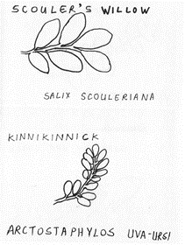
Extension:
Collect leaf samples and have students do a leaf rubbing and/or dry leaves and have them available in the classroom for students to explore with magnifying glasses, microscopes, etc.
Late primary and upper elementary activity extension: Students complete tracing activity and then create their own guide page for that species.
Update:
This activity aligns with the Wildsight Plant Awareness Project. Twenty-three plant signs on the Rotary Trail behind Alexander Park School connects citizens to local plants.

Local Animal Poster Project
Pre-activity: Use the Local Species Guide and other non-fiction texts to teach about non-fiction text features (for example, table of contents, labels, diagrams, index, glossary, etc.).
Guide activity:
Students choose a local animal to research in the Local Species Guide (an extension would be to find and use other non-fiction texts to use for research) and create a poster (see online resources for poster templates to download).
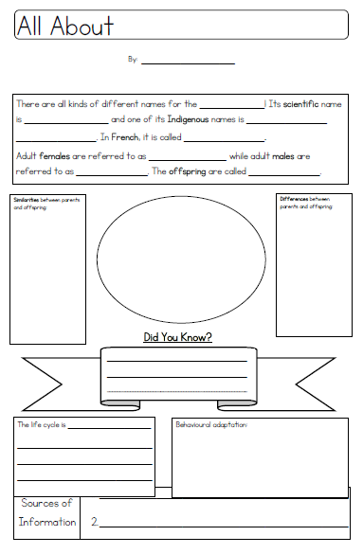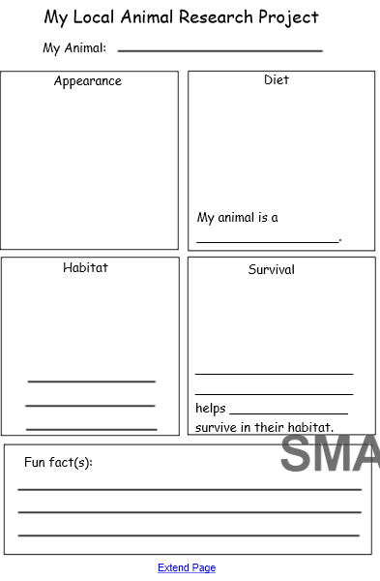
Extensions:
Students hold a “poster fair” or “learning celebration” and invite families to do a gallery walk and ask the students questions about their posters.
Students create a model of their animal or diorama of their animal’s habitat.
Organize an illustrator talk and invite Nick Laferriere in to your classroom talk about creating his illustrations.
Non-fiction Text Features Lesson
Brainstorm similarities and differences between fiction and non-fiction texts (you could use a Venn diagram to compare). Use the Local Species Guide and other non-fiction texts to teach about non-fiction text features (for example, table of contents, labels, diagrams, index, glossary, etc.) and the purpose of non-fiction texts. Have other guides and non-fiction texts available for students to explore and look for the features you’ve discussed.
Extensions:
Invite the author in to talk about creating a non-fiction text
Hold a “scavenger hunt” in which students have to use the table of contents or index to find a certain species or the glossary to find a definition.
Have students find different symbols used in the guide and discuss what they represent, mean and the purpose of using symbols. Students could create their own “fun facts” and “things to think about” for different species in the guide. While discussing the habitat symbol, explore different types of habitats and visit a variety of habitats in the local area to relate guide species to specific habitats in the area.
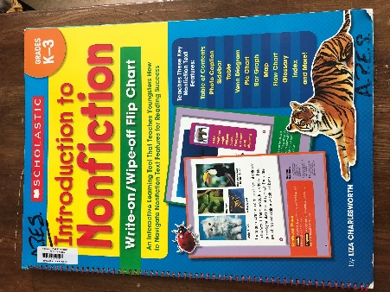
Secwepemc Plant Book
Print a copy of the Secwepemc Plant book template (see downloads for student book) for each student. Read and explore traditional uses of local area plants. Connect the student book to the Local Species Guide by having students match species from the Secwepemc Plant book to species in the Local Species Guide.
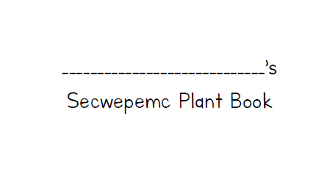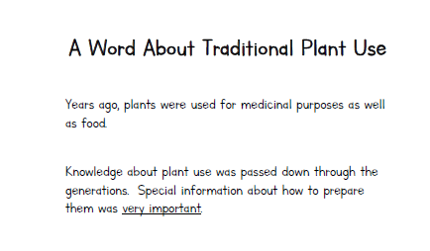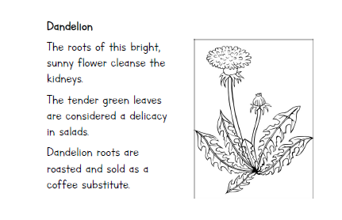
Extensions:
Use First Voices https://www.firstvoices.com/ to research Indigenous plant names and add to book.
Students make their own plant book with diagrams.
Read “Grandma’s Special feeling: Grandma teaches us how First Nations people used plants” by Karin Clark.
Local Species Guide Field Trip
Create a big book (or wall story) of local species that students identify on their field trip using the Local Species Guide. Connect the flora and fauna in the field guide to different local places.
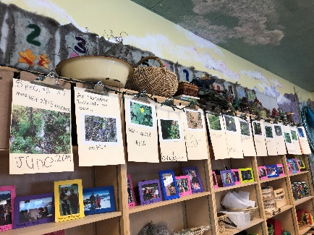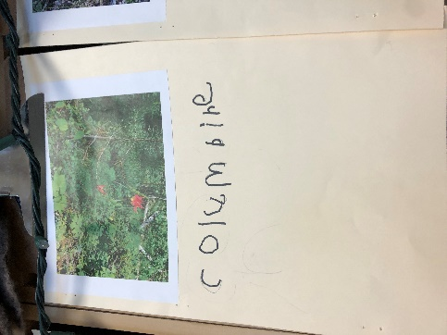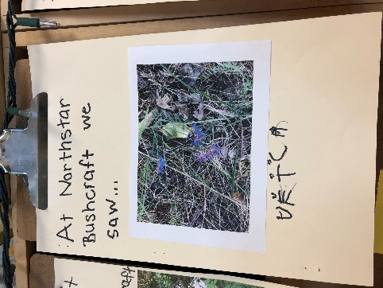
Late primary/ upper elementary extension: Students create their own page for a local species that they identified on the field trip including photo, diagram and written information.
Animal Tracks
Use the Local Species Guide to explore animal tracks. Take the guide out into the local area and search for common tracks using the guide to identify species. Discussions could include; seasonal differences for identifying animal tracks; the historical purposes of animal tracking; differences in animal tracks and the purpose of specific animal features and adaptations (for example webbed vs. non-webbed feet, retractable claws).
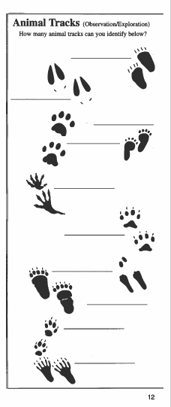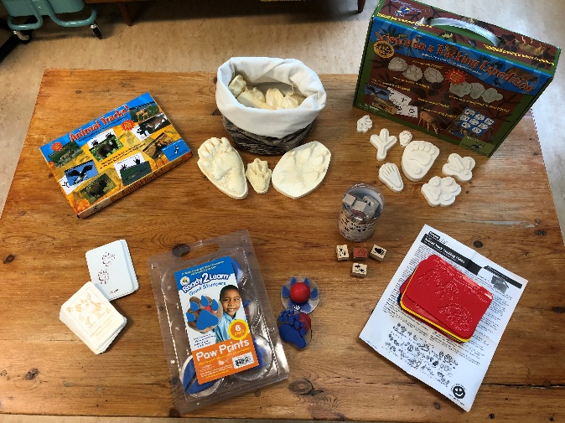
Extensions:
Make plaster animal track casts https://www.instructables.com/id/How-to-Make-a-Plaster-Cast-of-an-Animal-Track/
Have students use animal tracks rubbing plates to make an animal track rubbing (see animal tracks resources photo).
Animal tracks matching game- have students match a picture of the animal with a photo of their tracks.
Invite a hunter or trapper in to discuss tracking animals.
Read the following related children’s books:
“Who Has These Feet?” by Laura Hulbert and Erik Brooks
“Who Was Here? Discovering Wild Animal Tracks” by Mia Posada
“Tracks Count: A Guide to Counting Animal Prints” by Steve Engel and Alexander Petersen
“Whose Tracks Are These? A Clue Book of Familiar Forest Animals” by Jim Nail and Hyla Skudder
“Been There, Done That: Reading Animal Signs” by Jen Funk Weber and Andrea Gabriel
Use the Local Species Guide to replicate different species’ scat using plasticine or other molding materials. Safely collect and contain animal scat and discuss how you can use scat to discover an animal’s diet. An owl pellet would be an interesting provocation to begin a discussion about what scat is.
Create Your Own Local Species Guide Supplementary Page
For species that are not in the guide, students can create their own page for that species and include diagrams, photos, tracks, write-up, etc. For classes in other areas, students can explore the Golden Local Species Guide and identify which species are local to them as well and make supplementary pages for species specific to their area.
Extension:
Create a page for humans.
Upper elementary extension:
Local Species Guide Critique: What do you like about the guide? What would you keep? What would you improve?
Literature to use with the Local Field Guide:
There are so many children’s books that could be used in combination with the Local Field Guide, here are a few to get you started:
Other field guide/ non-fiction literature:
Small Adventures Journal by Keiko Brodeur
Wildlife Watcher Guide by Michael Leach and Meriel Lland
The Curious Nature Guide by Clare Walker Leslie
Finding Place An Illustrated Guide to Field Journaling by Lyn Baldwin
Keeping a Nature Journal by Clare Walker Leslie and Charles E. Roth
Handbook of the Canadian Rockies by Benn Gadd
Can you Hear the Trees Talking? Discovering the Hidden Life of the Forest by Peter Wohlleben
The Lost Words by Robert Macfarlane and Jackie Morris
How Do Animals Use Their Senses? By Alejandro Algarra and Rocio Bonilla
Animal Tracks of British Columbia by Ian Sheldon and Tamara Hartson

Fiction:
The Six Cedar Trees by Margot Landahl and Celestine Aleck
Sometimes I Feel Like a Fox by Danielle Daniel
Can You See Me? By Ted Lewin
Over and Under the Pond by Kate Messner and Christopher Silas Neal
Up in the Garden and Down in the Dirt by Kate Messner and Christopher Silas Neal
Over and Under the Snow by Kate Messner and Christopher Silas Neal
Keep Looking by Millicent Selsam, Joyce Hunt and Normand Chartier

Forest/ Plants Books
Over in the Forest Come and Take a Peek by Marianne Berkes and Jill Dubin
What Forest Knows by George Ella Lyon and August Hall
Looking Closely Through the Forest by Frank Serafini
Plants by Terry Jennings
The Reason for a Flower by Ruth Heller
A Seed is Sleepy by Dianna Hutts Aston and Sylvia Long
Tree Book: Learning to Recognize Trees of British Columbia Canadian Forest Service
The Cedar Tree: The Heart of Our People by Celestine Aleck
Who is the Forest For? By Donna Klockars
The Busy Tree by Jennifer ward and Lisa Falkenstern
Are Trees Alive? By Debbie S. Miller and Stacey Schuett
The Gift of the Tree by Alvin Tresselt and Henri Sorensen
Tree Song by H.E. Stewart
The Tree by Dana Lyons and David Danioth
Where Would I Be in an Evergreen Tree? By Jennifer Blomgrena and Andrea Gabriel
The Life of a Tree by Clare Hibbert
Books about Fauna
Let’s Walk With Bear by Margot Edwards and Leslie McGarry
Let’s Move With Bear and His Friends by Margot Edwards and Leslie McGarry
Kanyen’kehà:ka Clans by Michelle Corneau
Sharing Our World: Animals of the Native Northwest Coast by Native Explore
Discover the Animals: First Nations and Native Art Colouring and Learning Book by Native Explore

(Credit to Katie King for collating and recording these shared ideas.)

